EX NO: 21 HOSPITAL MANAGEMENT SYSTEM

USECASE DIAGRAM:

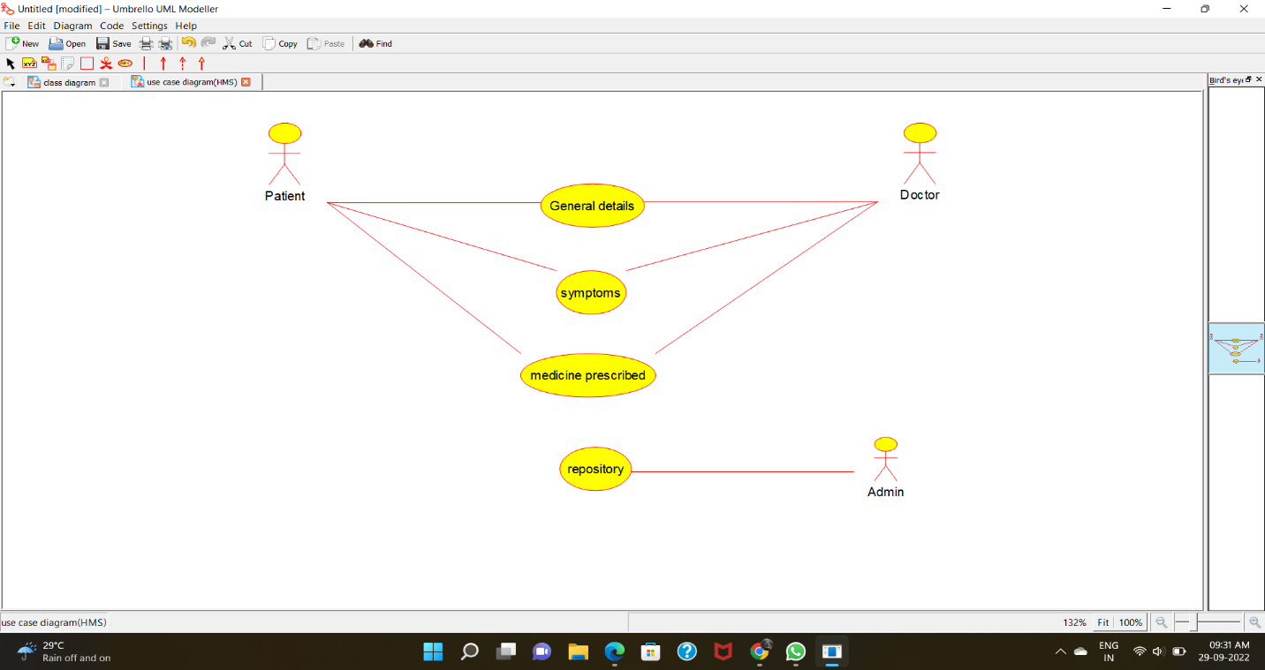

CLASS DIAGRAM: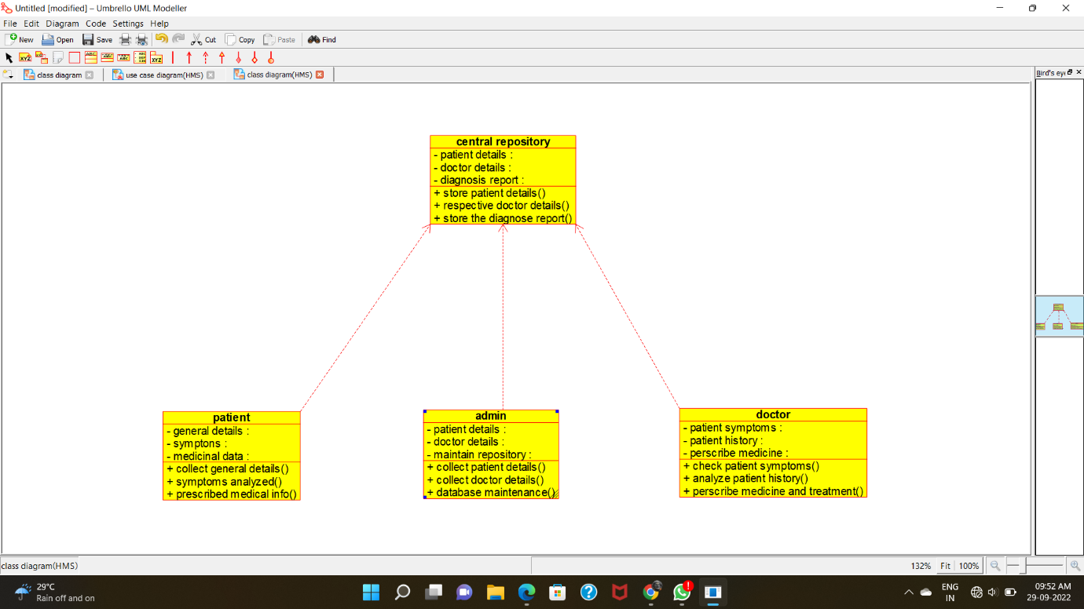

ACTIVITY DIAGRAM:

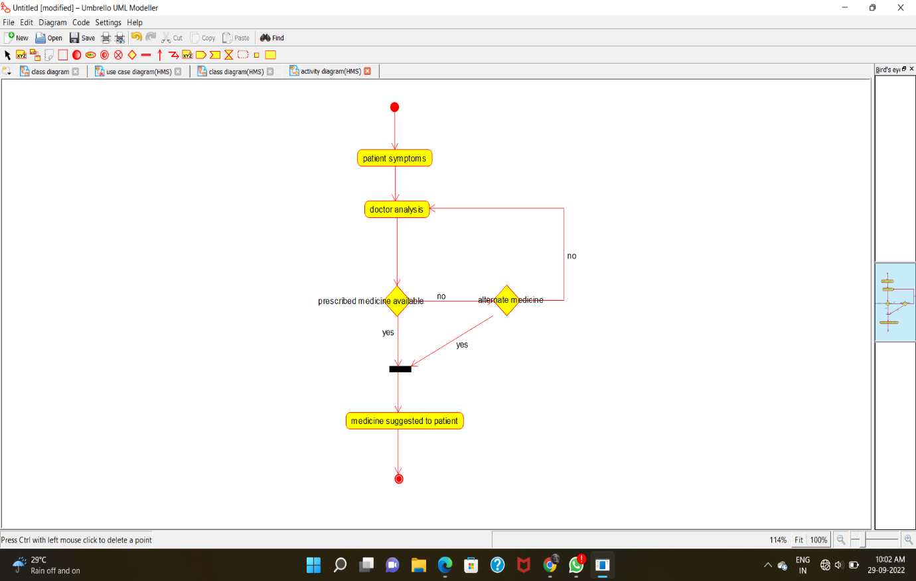

SEQUENCE DIAGRAM: 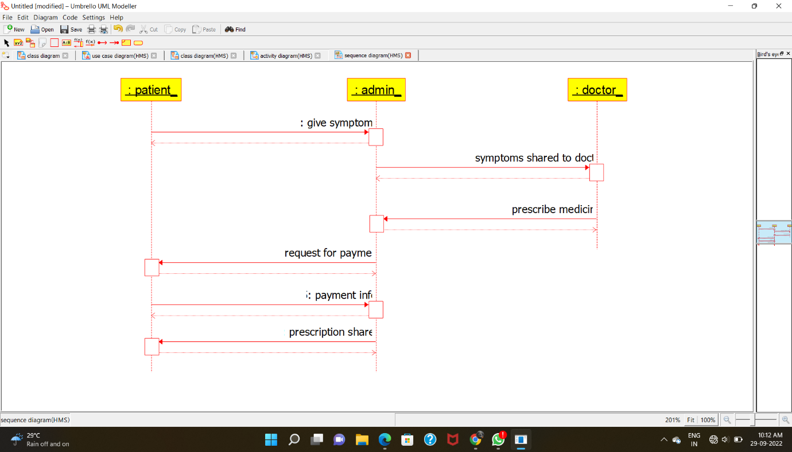

COLLABRATION DIAGRAM:

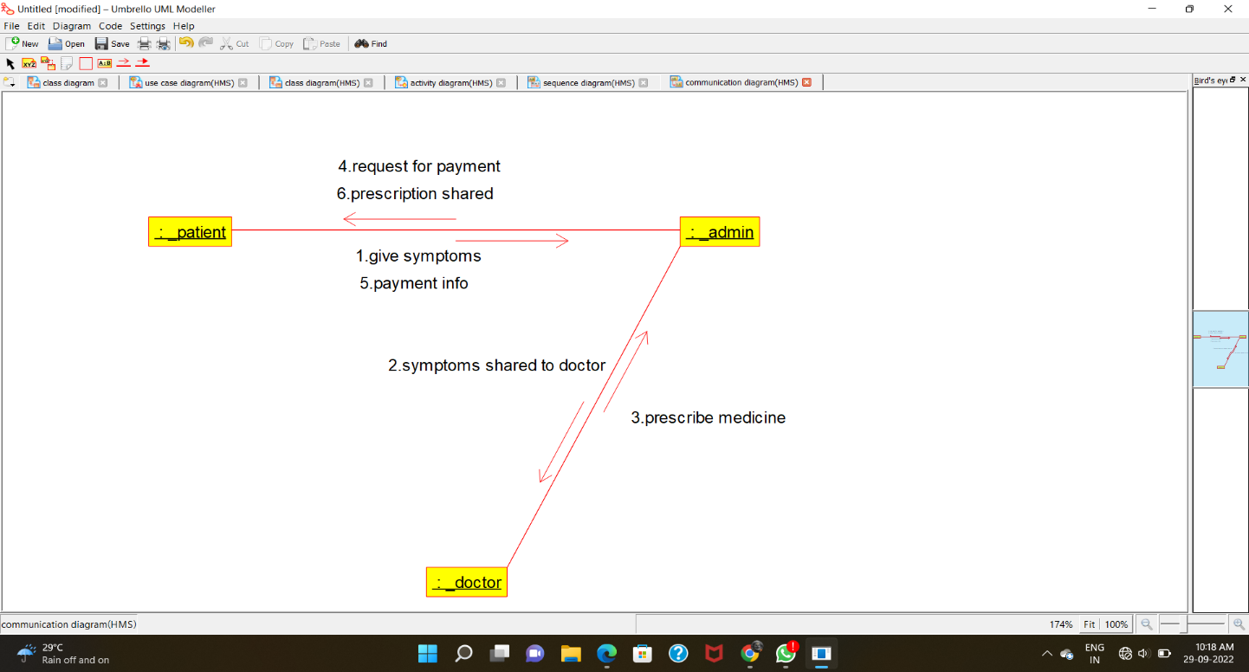

STATE-CHART DIAGRAM:

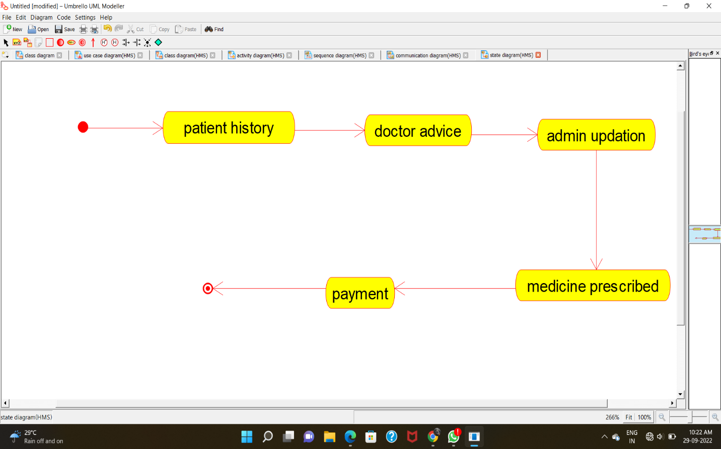

COMPONENT DIAGRAM:

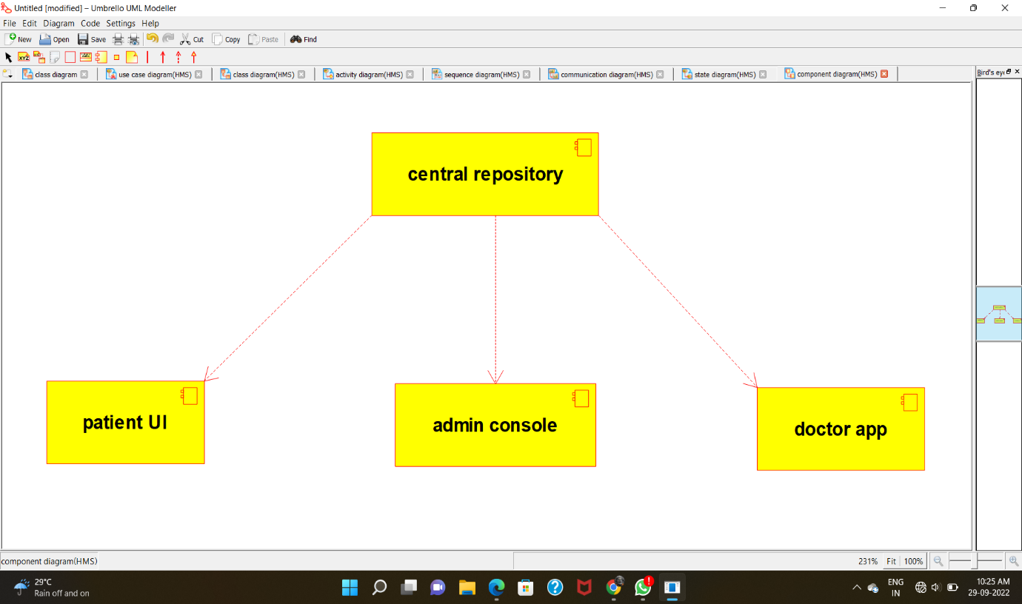

DEPLOYMENT DIAGRAM:

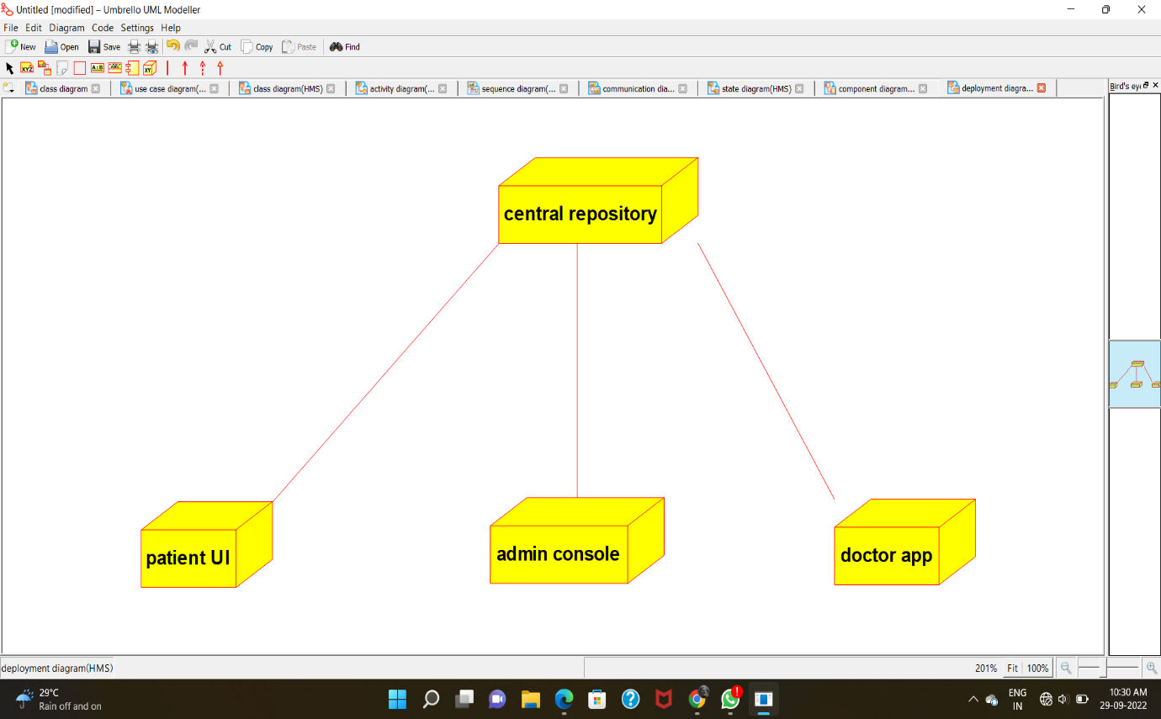

PROGRAM CODE:

CENTRAL REPOSITORY:

/**

* Class central_repository

*/

public class central_repository {

//

// Fields

//

private void patient_details;

private void doctor_details;

private void diagnosis_report;

//

// Constructors

//

public central_repository () { };

//

// Methods

//

//

// Accessor methods

//

/**

* Set the value of patient_details

* @param newVar the new value of patient_details

*/

private void setPatient_details (void newVar) {

patient_details = newVar;

}

/**

* Get the value of patient_details

* @return the value of patient_details

*/

private void getPatient_details () {

return patient_details;

}

/**

* Set the value of doctor_details

* @param newVar the new value of doctor_details

*/

private void setDoctor_details (void newVar) {

doctor_details = newVar;

}

/**

* Get the value of doctor_details

* @return the value of doctor_details

*/

private void getDoctor_details () {

return doctor_details;

}

/**

* Set the value of diagnosis_report

* @param newVar the new value of diagnosis_report

*/

private void setDiagnosis_report (void newVar) {

diagnosis_report = newVar;

}

/**

* Get the value of diagnosis_report

* @return the value of diagnosis_report

*/

private void getDiagnosis_report () {

return diagnosis_report;

}

//

// Other methods

//

/**

*/

public void store_patient_details()

{

}

/**

*/

public void respective_doctor_details()

{

}

/**

*/

public void store_the_diagnose_report()

{

}

}

**PATIENT:**

/**

* Class patient

*/

public class patient {

//

// Fields

//

private void general_details;

private void symptons;

private void medicinal_data;

//

// Constructors

//

public patient () { };

//

// Methods

//

//

// Accessor methods

//

/**

* Set the value of general_details

* @param newVar the new value of general_details

*/

private void setGeneral_details (void newVar) {

general_details = newVar;

}

/**

* Get the value of general_details

* @return the value of general_details

*/

private void getGeneral_details () {

return general_details;

}

/**

* Set the value of symptons

* @param newVar the new value of symptons

*/

private void setSymptons (void newVar) {

symptons = newVar;

}

/**

* Get the value of symptons

* @return the value of symptons

*/

private void getSymptons () {

return symptons;

}

/**

* Set the value of medicinal_data

* @param newVar the new value of medicinal_data

*/

private void setMedicinal_data (void newVar) {

medicinal_data = newVar;

}

/**

* Get the value of medicinal_data

* @return the value of medicinal_data

*/

private void getMedicinal_data () {

return medicinal_data;

}

//

// Other methods

//

/**

*/

public void collect_general_details()

{

}

/**

*/

public void symptoms_analyzed()

{

}

/**

*/

public void prescribed_medical_info()

{

}

}

**ADMIN:**

/**

* Class admin

*/

public class admin {

//

// Fields

//

private void patient_details;

private void doctor_details;

private void maintain_repository;

//

// Constructors

//

public admin () { };

//

// Methods

//

//

// Accessor methods

//

/**

* Set the value of patient_details

* @param newVar the new value of patient_details

*/

private void setPatient_details (void newVar) {

patient_details = newVar;

}

/**

* Get the value of patient_details

* @return the value of patient_details

*/

private void getPatient_details () {

return patient_details;

}

/**

* Set the value of doctor_details

* @param newVar the new value of doctor_details

*/

private void setDoctor_details (void newVar) {

doctor_details = newVar;

}

/**

* Get the value of doctor_details

* @return the value of doctor_details

*/

private void getDoctor_details () {

return doctor_details;

}

/**

* Set the value of maintain_repository

* @param newVar the new value of maintain_repository

*/

private void setMaintain_repository (void newVar) {

maintain_repository = newVar;

}

/**

* Get the value of maintain_repository

* @return the value of maintain_repository

*/

private void getMaintain_repository () {

return maintain_repository;

}

//

// Other methods

//

/**

*/

public void collect_patient_details()

{

}

/**

*/

public void collect_doctor_details()

{

}

/**

*/

public void database_maintenance()

{

}

}

DOCTOR:

/**

* Class doctor

*/

public class doctor {

//

// Fields

//

private void patient_symptoms;

private void patient_history;

private void perscribe_medicine;

//

// Constructors

//

public doctor () { };

//

// Methods

//

//

// Accessor methods

//

/**

* Set the value of patient_symptoms

* @param newVar the new value of patient_symptoms

*/

private void setPatient_symptoms (void newVar) {

patient_symptoms = newVar;

}

/**

* Get the value of patient_symptoms

* @return the value of patient_symptoms

*/

private void getPatient_symptoms () {

return patient_symptoms;

}

/**

* Set the value of patient_history

* @param newVar the new value of patient_history

*/

private void setPatient_history (void newVar) {

patient_history = newVar;

}

/**

* Get the value of patient_history

* @return the value of patient_history

*/

private void getPatient_history () {

return patient_history;

}

/**

* Set the value of perscribe_medicine

* @param newVar the new value of perscribe_medicine

*/

private void setPerscribe_medicine (void newVar) {

perscribe_medicine = newVar;

}

/**

* Get the value of perscribe_medicine

* @return the value of perscribe_medicine

*/

private void getPerscribe_medicine () {

return perscribe_medicine;

}

//

// Other methods

//

/**

*/

public void check_patient_symptoms()

{

}

/**

*/

public void analyze_patient_history()

{

}

/**

*/

public void perscribe_medicine_and_treatment()

{

}

}